Article 1. Authority. Under the authority granted in 24 V.S.A. § 2291(20), the Town of Kirby hereby adopts the following policy concerning conflicts of interest and ethical conduct.

Article 2. Purpose. The purpose of this policy is to ensure that the business of this municipality will be conducted in such a way that no public officer of the municipality will gain a personal or financial advantage from his or her work for the municipality and so that the public trust in its officers will be preserved. It is also the intent of this policy to ensure that all decisions made by public officers are based on the best interests of the municipality.

Article 3. Application. This policy applies to all individuals elected or statutorily-appointed to perform executive, administrative, legislative, or quasi-judicial functions of the Town of Kirby.

Article 4. Definitions. For the purposes of this policy, the following definitions shall apply:

A. Conflict of interest means any of the following:

- A real or seeming incompatibility between a public officer’s private interests and his or her public or fiduciary interests to the municipality he or she serves. A conflict of interest arises when there is a direct or indirect personal or financial interest of a public officer or a person or group closely tied with the officer including his or her spouse, household member, child, stepchild, parent, grandparent, grandchild, sibling, aunt or uncle, brother- or sister-in-law, business associate, or employer or employee in the outcome of an official act or action, or any other matter pending before the officer or before the public body in which the public officer holds office. A conflict of interest may take any of the four following forms:
  - A direct financial conflict of interest arises when a public officer acts on a matter that has a direct financial impact on that officer.
  - An indirect financial conflict of interest arises when a public officer acts on a matter that has a financial impact on a person or group closely tied to the officer.
  - A direct personal conflict of interest arises when a public officer acts on a matter that has a direct impact on the officer in a non-financial way but is of significant importance to the officer.
  - An indirect personal conflict of interest arises when a public officer acts on a matter in which the officer’s judgment may be affected because of a familial or personal relationship or membership in some organization and a desire to help that person or organization further its own interests.

2. A situation where a public officer has publicly displayed a prejudgment of the merits of a particular quasi-judicial proceeding. This shall not apply to a member’s particular political views or general opinion on a given issue.

3. A situation where a public officer has not disclosed ex parte communication(s) related to a quasi-judicial proceeding that is before the body to which that officer belongs.

A "conflict of interest" does not arise in the case of an official act or action in which the public officer has a personal or financial interest in the outcome, such as in the establishment of a tax rate, that is no greater than that of other persons generally affected by the decision.

B. Emergency means an imminent threat or peril to the public health, safety, or welfare.

C. Ex Parte Communication means direct or indirect communication between a member of a public body and any party, party’s representative, party’s counsel or any person interested in the outcome of a quasi-judicial proceeding, that occurs outside the proceeding and concerns the substance or merits of the proceeding.

D. Official act or action means any legislative, administrative or quasi-judicial act performed by any public officer while acting on behalf of the municipality. This term does not apply to ministerial acts or actions wherein no discretionary judgment is exercised.

E. Public body means any board, council, commission, or committee of the municipality.

F. Public interest means an interest of the municipality, conferred generally upon all residents of the municipality.

G. Public officer means a person elected or statutorily-appointed to perform executive, administrative, legislative, or quasi-judicial functions for the municipality. This term does not include municipal employees.

H. Quasi-judicial proceeding means a case in which the legal rights of one or more persons who are granted party status are adjudicated, which is conducted in such a way that all parties have opportunities to present evidence and to cross-examine witnesses presented by other parties, and which results in a written decision, the result of which is appealable by a party to a higher authority.

Article 5. Prohibited Conduct.

A. A public officer shall not participate in any official act or action if he or she has a conflict of interest, whether real or perceived, in the matter under consideration.

B. A public officer shall not personally – or through any member of his or her household, business associate, employer or employee – represent, appear for, or negotiate in a private capacity on behalf of any person or organization that has an interest in an official act or action pending before the public body in which the public officer holds office.

C. A public officer shall not accept gifts or other offerings for personal gain by virtue of his or her public office that are not available to the public in general.

D. A public officer will not request or accept any reward, gift, or favor for taking an official act or action or advocating for or against an official act or action.

E. A public officer shall not use resources unavailable to the general public – including but not limited to municipal staff time, equipment, supplies, or facilities – for private gain or personal purposes.

F. A public officer who is a member of a public body shall not give the impression that he or she has the authority to make decisions or take actions on behalf of that body.

Article 6. Disclosure. A public officer who, while serving on a public body, may have a conflict of interest, whether real or perceived, in a matter under consideration by that public body shall, prior to taking an official act or action or participating in any official act or action on the matter, publicly disclose at a public meeting or public hearing that he or she has an actual or perceived conflict of interest in the matter under consideration and disclose the nature of the actual or perceived conflict of interest. Alternatively, a public officer may request that another public officer recuse him or herself from a matter due to a conflict of interest, whether real or perceived.

Article 7. Consideration of Recusal. Once there has been a disclosure of an actual or perceived conflict of interest, other public officers shall be afforded an opportunity to ask questions or make comments about the situation. If a previously unknown conflict is discovered during a meeting or hearing conducted by a public body of the municipality, the public body shall take evidence pertaining to the conflict and, if appropriate, adjourn to an executive session to address the conflict.

Article 8. Recusal.

A. Recusal of Appointed and Elected Officers. After taking the actions listed in Articles 6 and 7, a public officer, whether appointed or elected, shall declare whether he or she will recuse him or herself and explain the basis for that decision. If the public officer has an actual or perceived conflict of interest but believes that he or she is able to act fairly, objectively, and in the public interest, in spite of the conflict, he or she shall state why he or she believes that he or she is able to act in the matter fairly, objectively, and in the public interest. Otherwise, the public officer shall recuse him or herself from the matter under consideration. A public officer that recuses him or herself may, but not must, explain the basis for that decision.

B. Recusal of Appointed Officers. The failure of an appointed public officer to recuse himself or herself in spite of a conflict of interest, whether real or perceived, may be grounds for discipline or removal from office.

Article 9. Recording. The minutes of the meeting or the written decision / minutes from the meeting / hearing shall document the actions taken in Articles 6 through 8.

Article 10. Post-Recusal Procedure.

A. A public officer who has recused himself or herself from participating in an official act or action by a public body shall not sit with the public body, deliberate with the public body, or participate in the discussions about that official act or action in any manner in his or her capacity as a public officer, though such member may still participate as a member of the public or private party, if applicable.

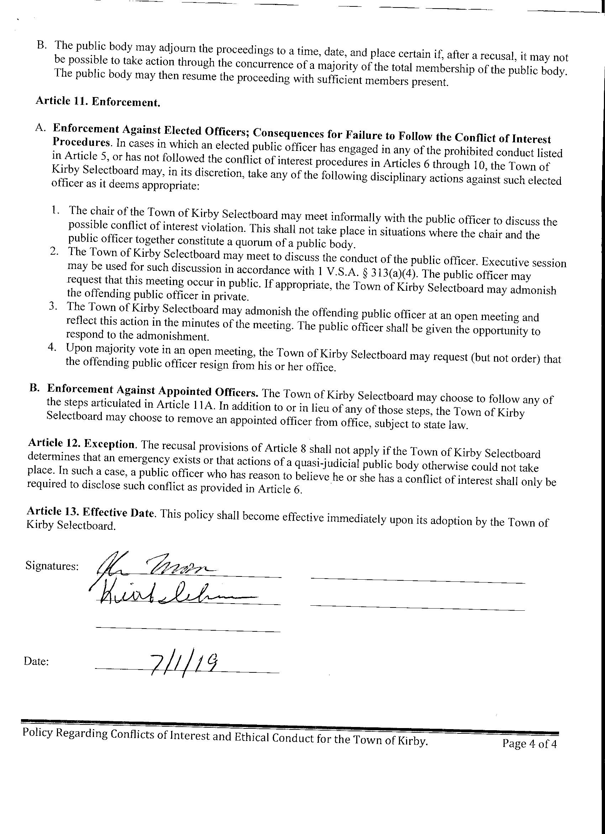

Such request shall not be considered an order for the officer to recuse him or herself.
Each member of an elected public body is independently elected and answers only to the voters. Therefore, unless there is a local ordinance or charter provision that states otherwise, the remaining members of the body may not force recusal. They may only express their opinion about the subject and/or privately or publicly admonish a fellow member who fails to handle conflicts appropriately.
Certain appointed public officers such as a Zoning Administrator and members of the Zoning Board of Adjustment or Development Review Board may only be removed for cause and after being afforded with procedural due process protections including notice and a reasonable opportunity to be heard.

