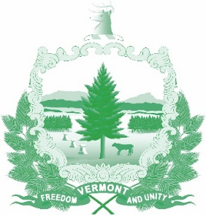
Vermont State Ethics Commission
Minutes of September 2, 2020 Meeting (approved)

1. Call to Order: The September 2, 2020 meeting, held via Zoom, was called to order by Commission Chair Julie Hulburd at 10:03 a.m. Also present for the meeting were Commission members Christopher Davis and Paul Erlbaum, and Executive Director Larry Novins. Commission members Sarah Biolsi Vangel and Michele Eid were not present.
2. Approval of Minutes: On the motion of Christopher Davis second by Paul Erlbaum, the minutes of the August 2020 meeting were approved with one date correction.
3. Public Comment: None
4. Executive Director’s Report: Larry Novins outlined his efforts to make sure that as many State of Vermont employees as possible received direct communication of the Ethics Commission’s request for their input and comment on the proposed draft code of ethics. Judicial branch employees did not receive forwarded copies of the request for public input.
Novins is compiling the comments into an annotated version of the draft code of ethics. In the next week or two he will add to the annotation his responses to comments received and his recommendations about which parts of the code should be amended or revised. Of note, the portions of the draft code receiving the most comments were those dealing with “post-government employment” and “gifts.” See below.
Novins informed the Commission about his communications with judicial branch representatives and their position that the draft code should not apply to judicial branch employees. The Supreme Court has clear disciplinary authority over judges and attorneys, but whether separation of powers concerns excludes judicial employees is subject to debate. His annotated code will contain the arguments for and against applying the code to judicial branch employees.
5. Code of Ethics (Phase II) Comments received to date: The Commission has received copies of comments received so far and will receive an updated annotated version of the code to review for its next meeting. The Commission hopes to review and approve changes at its October meeting. Then a final proposed draft will be circulated which the Commission hopes to give its final approval to at its November meeting. Then the draft can be submitted to the legislature.
6. Other business: None
7. Executive Session to Discuss Complaints and Guidance Requests: On the motion of Paul Erlbaum, second by Christopher Davis, the Commission went into executive session to discuss complaints and guidance requests. These matters are confidential per 3 V.S.A. §§ 1221(d), 1223(c), and 1225(a)(3). On the motion of Christopher Davis, second by Paul Erlbaum, the Commission voted to conclude the Executive Session and return to open session.
8. Adjournment: Christopher Davis moved to adjourn, second by Paul Erlbaum. The meeting adjourned at 11:08 a.m.
Next Meetings: Next regular monthly meeting will be on Wednesday, October 7, 2020 at 10:00 a.m.

