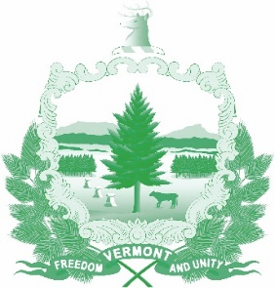
Vermont State Ethics Commission
Minutes of March 11, 2020 Meeting (approved)

1. Call to Order: The meeting, held at the Ethics Commission office 6 Baldwin St. Montpelier, was called to order by Commission Chair Julie Hulburd at 10:45 a.m. Also present for the meeting were Commission members Paul Erlbaum by telephone and Chris Davis. Executive Director Larry Novins joined the meeting at 10:54 a.m. after returning from the State House.
2. Approval of Minutes: On the motion of Paul Erlbaum, second by Chris Davis, the minutes of the February 5, 2020 meeting were approved.
3. Public Comment: None.
4. Executive Director’s Report: Julie Hulburd began the discussion until Larry Novins returned from the State House. Larry Novins then briefed the Commission on the progress of the two bills regarding the Ethics Commission, S.198 and H.634. There were several hearings on S.198. It was voted out of the Senate Government Operations committee, but brought back and changes made. The changes included asking the Ethics Commission to provide the General Assembly with “options for implementation and enforcement of that proposed State Code of Ethics.” The Committee voted the amended bill out over Novins’s objections to the new section which he believed could act as a poison pill to passage of a code of ethics. That bill now awaits a hearing in the Senate Finance Committee which may consider it on March 12.
H.634 received its first review at the House Government Operations Committee on March 11. The discussion may result in one or two modifications to the areas in which the Ethics Commission (Executive Director) may provide guidance or advisory opinions.
Both bills contain provisions extending the funding mechanism for the Ethics Commission.
5. Code of Ethics and Statutes Phase II Novins updated the Commission on further revisions to “Phase II” of the Ethics Code statutory draft and the revision draft of the Code of Ethics - General Principles.
6. Terms of Office: Discussion deferred until April so all Commission members can participate.

7. Executive Session to Discuss Complaints and Guidance Requests: On the motion of Chris Davis, second by Paul Erlbaum, the Commission went into executive session to discuss complaints and guidance requests. These matters are confidential per 3 V.S.A. §§ 1221(d), 1223(c), and 1225(a)(3). On the motion of Chris Davis second by Paul Erlbaum the Commission voted to conclude the Executive Session and return to open session.
Other Business: None.
Adjournment: Chris Davis moved to adjourn, second by Paul Erlbaum. The meeting adjourned at 11:26 a.m.
Next Meeting: Wednesday, April 1, 2020 at 10:00 a.m.

