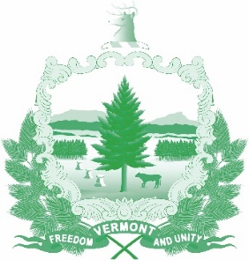
Vermont State Ethics Commission
Minutes of August 5, 2020 Meeting

1. Call to Order: The meeting, held via Zoom, was called to order by Commission Chair Julie Hulburd at 10:16 a.m. Also present for the meeting were Commission members Christopher Davis, Sarah Biolsi Vangel, Paul Erlbaum, Michele Eid, and Executive Director Larry Novins.
2. Approval of Minutes: On the motion of Paul Erlbaum, second by Chris Davis, the minutes of the July 3, 2020 meeting were approved. Sarah Vangel who did not attend that meeting abstained.
3. Public Comment: None
4. Executive Director’s Report: Larry Novins explained the press release announcing that the Commission is seeking public comment to the proposed statutory code of ethics. He shared the revisions to the website pertaining to the draft code and how anyone can comment to the code’s provisions. Novins detailed his continuing efforts to make sure that all State of Vermont employees are notified of their ability to comment. Previous notices were sent to agency and department heads to be forwarded to their personnel. Still, it appears that many state employees have not heard about the proposed ethics code and solicited public comment. Novins continues his efforts to obtain permission to send a state-wide all employee email out. He explained how the public hearing scheduled for August 12 was set up and how it will be handled on Zoom. Other information: The office now has a cell phone to which all calls to the land line are forwarded automatically. Now no calls are missed. Novins now has a Westlaw account for Ethics Commission work.
5. Code of Ethics (Phase II) Comments received to date: The Commission reviewed and discussed comments received so far. No changes will be made until the conclusion of the public comment period.
6. Other business:
7. Executive Session to Discuss Complaints and Guidance Requests: On the motion of Sarah Vangel, second by Michele Eid, the Commission went into executive session to discuss complaints and guidance requests. These matters are confidential per 3 V.S.A. §§ 1221(d), 1223(c), and 1225(a)(3). On the motion of Michele Eid and Paul Erlbaum the Commission voted to conclude the Executive Session and return to open session.
8. Adjournment: Michele Eid moved to adjourn, second by Chris Davis. The meeting adjourned at 11:42 a.m.
Next Meetings: Public Hearing on Proposed Ethics Code, August 12, 2020 at 10:00 a.m. Next regular monthly meeting September 2, 2020 at 10:00 a.m.

