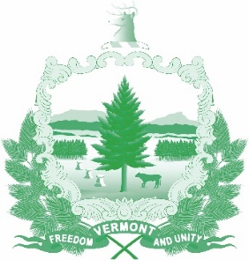

Vermont State Ethics Commission
Agenda for Meeting January 8, 2020 10:00 AM
6 Baldwin Street Rm. 315
Montpelier, VT

- Call to Order:
- Approval of minutes of December 4, 2019:
- Public Comment:
- Executive Director's Report:
- Annual report, Review of Draft:
- Code of Ethics, Review:
- Statutes, draft revisions, Update:
- Executive Session to Discuss Complaints and Guidance Requests:
- Other business: Discussion of 2019 COGEL conference
- Adjournment:

Next Meeting: February 5, 2020 at 10:00 a.m.

