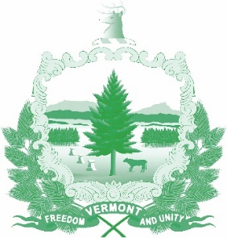

Vermont State Ethics Commission
Agenda for Meeting December 4, 2019 10:00 AM
6 Baldwin Street Rm. 315
Montpelier, VT

- Call to Order:
- Approval of minutes of November 6, 2019:
- Public Comment:
- Executive Director's Report:
- Website:
- Operating Procedures Review, Revision Commission Finances:
- Statutes, draft revisions: Phase II
- Annual report: Outline and ideas
- Executive Session to Discuss Complaints and Guidance Requests:
- Other business:
- Adjournment:

Next Meeting: Different Day: Second Monday, January 8, 2020 at 10:00 a.m.

