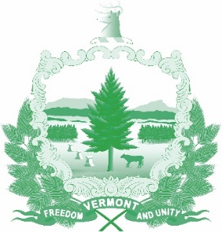

Vermont State Ethics Commission
Agenda for Meeting October 7, 2020 10:00 AM
Remote Attendance*
Montpelier, VT
Agenda

- Call to Order:
- Approval of minutes of September 2, 2020 meeting:
- Public Comment:
- Executive Director's Report:
- Code of Ethics (statutes Phase II)- review of public input and comments received, and proposed revisions.
- Terms of office discussion:
- Annual Report discussion:
- Other business:
- Executive Session to Discuss Complaints and Guidance Requests
- Adjournment:

To attend by telephone, call 1-929-205-6099. On the morning of the meeting, the meeting ID number and password you will need will be posted on the Ethics Commission web site under “Meetings.” Directions for attending the meeting via internet video will be posted there as well.

