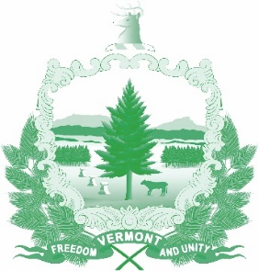

Vermont State Ethics Commission
Agenda for Meeting March 4, 2020 10:00 AM
6 Baldwin Street Rm. 315
Montpelier, VT
Agenda

- Call to Order:
- Approval of minutes of February 5, 2020:
- Public Comment
- Executive Director's Report
- Code of Ethics (statutes Phase II)
- Terms of office discussion
- Executive Session to Discuss Complaints and Guidance Requests
- Other business:
- Adjournment:

Next Meeting: April 1, 2020

