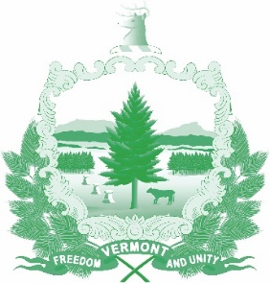

Vermont State Ethics Commission
Agenda for Meeting March 3, 2021 10:00 AM
Remote Attendance*
Montpelier, VT
Agenda

- Call to Order:
- Approval of minutes of February 3, 2021 meeting:
- Public Comment:
- Executive Director's Report:
- Annual Report discussion:
- Statutory proposals for 2021:
- Other business: Executive Session to Discuss Complaints and Guidance Requests
- Adjournment:

On the morning of the meeting, the Zoom meeting ID number and password needed will be posted on the Ethics Commission web site under “Meetings.” Directions for attending the meeting via internet video or by telephone will included.

