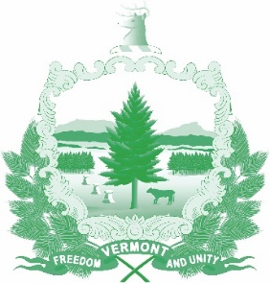

Vermont State Ethics Commission
Agenda for Meeting May 6, 2020 at 10:00 a.m.
Remote Attendance*
Montpelier, VT
Agenda

- Call to Order:
- Approval of minutes of April 1, 2020:
- Public Comment:
- Covid-19 Accommodations: Meeting notices, public comment, and invitations (including telephone #)
- Executive Director's Report:
- Code of Ethics (statutes Phase II), Legislative update:
- Executive Session to Discuss Complaints and Guidance Requests:
- Other business:
- Adjournment:

Next Meeting: June 3, 2020

**To attend by telephone, call 1-929-205-6099. The meeting ID number and password you will need will be posted on the Ethics Commission web site under “Meetings” on the day of the meeting. Directions for attending the meeting via internet video will be posted at the same time and location.

