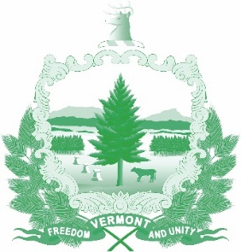

Vermont State Ethics Commission
Agenda for Meeting July 1, 2020 at 10:00 a.m.
Remote Attendance*
Montpelier, VT
Agenda

- Call to Order:
- Approval of minutes of June 3, 2020:
- Public Comment:
- Executive Director's Report: Ethics Code - Website, press release, public input
- Code of Ethics (statutes Phase II), Legislative update:
- Commission member terms, review, appointments:
- Other business:
- Executive Session to Discuss Complaints and Guidance Requests:
- Adjourn:

Next Meeting: August 5, 2020

**To attend by telephone, call 1-929-205-6099. On July 1, the meeting ID number and password you will need will be posted on the Ethics Commission web site under “Meetings.” Directions for attending the meeting via internet video will be posted there as well.

