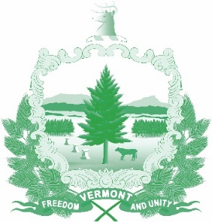

Vermont State Ethics Commission
Agenda for Meeting January 6, 2021 10:00 AM
Remote Attendance*
Montpelier, VT
Agenda

- Call to Order:
- Approval of minutes of November 4, 2020 meeting:
- Public Comment:
- Executive Director's Report:
- Annual Report discussion:
- Other business: reimbursement form reminder
- Executive Session to Discuss Complaints and Guidance Requests
- Adjournment:

On the morning of the meeting, the Zoom meeting ID number and password needed will be posted on the Ethics Commission web site under “Meetings.” Directions for attending the meeting via internet video or by telephone will included.

