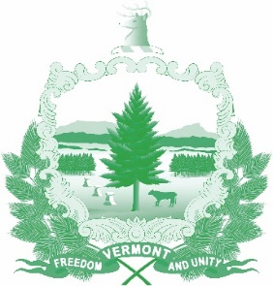

Vermont State Ethics Commission
Agenda for Meeting August 5, 2020 at 10:00 a.m.
Remote Attendance*
Montpelier, VT
Agenda

- Call to Order:
- Approval of minutes of July 1,2020:
- Public Comment:
- Executive Director's Report: Ethics Code - Website, press release, public input
- Code of Ethics (statutes Phase II), Comments received to date:
- Other business:
- Executive Session to Discuss Complaints and Guidance Requests:
- Adjourn:

Next Event: Public Hearing August 12, 2020 at 10:00 a.m.

Next Meeting: September 2, 2020 at 10:00 a.m.

**To attend by telephone, call 1-929-205-6099. On August 5, 2020, the meeting ID number and password needed will be posted on the Ethics Commission web site under “Meetings.” Directions for attending the meeting via internet video will be posted there as well.

