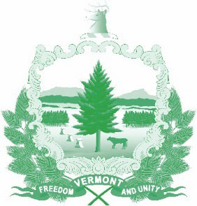

Vermont State Ethics Commission

**Agenda for Meeting January 8, 2025, at 10:00 am**

**Remote Attendance\***

**Montpelier, VT**

1. Call to Order
2. Approval of October 2nd and December 18th, Meeting Minutes
3. Public Comment
4. Welcome Commissioner Stevens
5. Executive Director’s Report
   * Municipal Ethics Update
   * Financial Disclosures
   * Upcoming Legislative Session
6. Executive Session
   * Update on complaints and request for Guidance
7. Adjournment