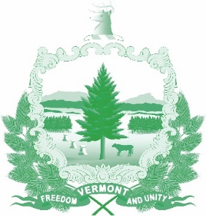

Vermont State Ethics Commission
Agenda for Meeting May 5, 2021 10:00 AM
Remote Attendance*???
Montpelier, VT
Agenda

- Call to Order:
- Approval of Minutes of April 7, 2021:
- Public Comment:
- Executive Director's Report:
- tbd:
- tbd:
- Executive Session to Discuss Complaints and Guidance Requests:
- Other business:
- Adjournment:

Next Meeting: June 2, 2021

* On the morning of the meeting, the Zoom meeting ID number and password needed will be posted on the Ethics Commission web site under “Meetings.” Directions for attending the meeting via internet video or by telephone will included.

