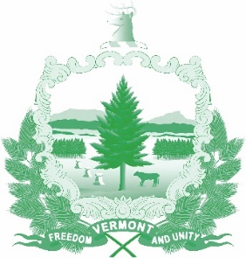
Vermont State Ethics Commission
Agenda for Meeting October 5, 2022, 10:00 AM
Remote Attendance*
Montpelier, VT

- Call to Order
- Approval of Approval of July 6, 2022, and September 7, 2022, Meeting Minutes
- Public Comment
- Executive Director's Report
- Discussion re draft Advisory Opinion procedures
- Training update
- FY24 budget
- Per diem increase

- Executive Session
- Update on Complaints and requests for Guidance
- Adjournment

