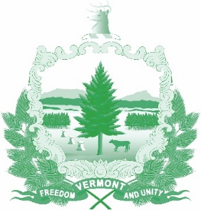

Vermont State Ethics Commission
Meeting February 5, 2020 10:00 AM
6 Baldwin Street Rm. 315
Montpelier, VT

Agenda

- Call to Order:
- Approval of minutes of January 8, 2020:
- Public Comment
- Executive Director's Report
- Code of Ethics and Statutes Phase II
- Terms of office discussion
- Executive Session to Discuss Complaints and Guidance Requests
- Other business:
- Adjournment:

Next Meeting: March 5, 2020

