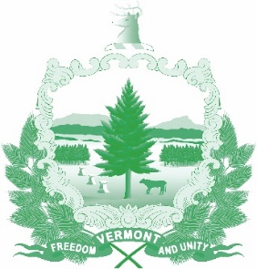

Vermont State Ethics Commission
Agenda for Meeting June 3, 2020 at 10:00 a.m.
Remote Attendance*
Montpelier, VT
Agenda

- Call to Order:
- Approval of minutes of May 6, 2020:
- Public Comment:
- Executive Director's Report:
- Code of Ethics (statutes Phase II), Legislative update:
- Executive Session to Discuss Complaints and Guidance Requests:
- Other business:
- Adjournment:

Next Meeting: July 1, 2020

**To attend by telephone, call 1-929-205-6099. On June 3, the meeting ID number and password you will need will be posted on the Ethics Commission web site under “Meetings.” Directions for attending the meeting via internet video will be posted there as well.

