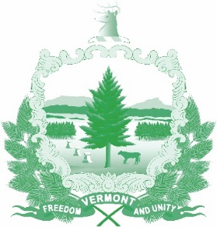

Vermont State Ethics Commission
Agenda for Meeting April 1, 2020 10:00 AM
Remote Attendance*
Montpelier, VT
Agenda

- Call to Order:
- Approval of minutes of March 4, 2020:
- Public Comment:
- Covid-19 Accommodations:
- Executive Director's Report:
- Code of Ethics (statutes Phase II), Legislative update:
- Terms of office discussion:
- Executive Session to Discuss Complaints and Guidance Requests:
- Other business:
- Adjournment:

Next Meeting: May 6, 2020

*To attend this meeting, go to Ethics Commission web site, then “Meetings: Agendas and Minutes” for directions. On May 1, 2020 “how to attend” information will be posted there.

