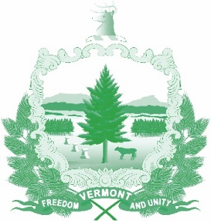
Vermont State Ethics Commission
Minutes of January 8, 2020 Meeting

1. Call to Order: The meeting, held at the Ethics Commission office 6 Baldwin St. Montpelier, was called to order by Commission Chair Julie Hulburd at 10:08 a.m. Also present for the meeting were Commission members Christopher Davis, Sarah Biolsi Vangel (by telephone), Michele Eid, and Executive Director Larry Novins.
2. Approval of Minutes: On the motion of Michele Eid, second by Sarah Biolsi Vangel, the minutes of the December 4, 2019 meeting were approved.
3. Public Comment: None
4. Executive Director’s Report: Larry Novins reviewed his work on a statutory code of ethics, and preparation of the Commission’s annual report. There is a House legislative ethics training planned for some time this session. He reviewed inquiries to the office.
5. Annual Report, Review of Draft: On the motion of Sarah Biolsi Vangel and Michele Eid, second by Chris Davis, the Commission voted unanimously to approve the Executive Director’s draft of the annual report, pending some minor language revisions discussed at the meeting.
6. Code of Ethics, Review: The Ethics Commission discussed possible amendment to section 12 regarding how public servants should handle decisions where there is a conflict of interest. And additional sentence which clarifies that a public servant may not influence a decision which the public servant is recused from making was informally approved. More wordsmithing is needed on this section before a change can be formally approved. In the meantime, a limited number of “inserts” of the current code will be printed for distribution in the near future.
7. Statutes, draft revisions: The draft bill sent to the legislature at the end of November has two sponsors in the House and should be appearing very soon. In the Senate, a bill requiring the Commission to submit a draft ethics code for adoption by statute has been introduced. On Friday, January 10, Larry Novins and Julie Hulburd will appear before the Senate Government Operations Committee.
8. Executive Session to Discuss Complaints and Guidance Requests: On the motion of Chris Davis, second by Michele Eid, the Commission went into executive session to discuss complaints and guidance requests. These matters are confidential per 3 V.S.A. §§ 1221(d), 1223(c), and 1225(a)(3). On the motion of Michele Eid and Sarah Biolsi Vangel the Commission voted to conclude the Executive Session and return to open session.
9. Other Business: Commissioner Michele Eid and Larry Novins briefed the Commission on the December Council on Government Ethics Laws conference held in Chicago. The meeting was very useful and provided good perspective of how our Ethics Commission functions compared to those of other jurisdictions.
10. Adjournment: Chris Davis moved to adjourn, second by Michele Eid and Sarah Biolsi Vangel. The meeting adjourned at 11:22 a.m.

Next Meeting: February 5, 2020 at 10:00 a.m.

