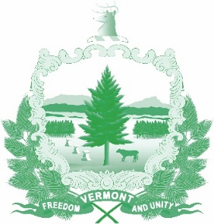
Vermont State Ethics Commission
Agenda
Meeting September 4, 2019 10:00 AM
6 Baldwin Street Rm. 315
Montpelier, VT

- Call to Order:
- Approval of minutes of last meeting (date):
- Public Comment
- Executive Director's Report
- Review of General Principles
- Legislative Recommendations: Status
- Website
- Financial and Spending Policies
- Advisory Opinions: Should AO 18-01 be withdrawn?
- Executive Session to Discuss Complaints and Guidance Requests
- Other business:
- Adjournment:

